CALENDAR ACTIVITIES SUBJECT TO CHANGE DUE TO CIRCUSTANCES OUT OF OUR CONTROL | 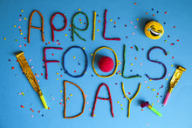 | 1  8:00 BOWLING PRACTICE  9:00 CARDS  11:30 LUNCH  12:30 BINGO | 2  8:00 BOWLING PRACTICE  9:00 CARDS  11:30 LUNCH  12:30 CART BINGO  GAME DAY | 3    This Photo by Unknown Author is licensed under CC BY-NC-ND  CENTER CLOSED
6  8:00 BOWLING PRACTICE  9:00 CARDS  9:30 EASTER CRAFT W/ ASSET PROTECTORS  11:30 LUNCH  12:30 BINGO | 7  8:00 BOWLING PRACTICE  9:00 CARDS  11:30 LUNCH | 8  8:00 BOWLING PRACTICE  9:00 CARDS  10:30 CENTER MEETING  11:30 LUNCH  12:30 BINGO W/ TINA LOUISE  STREET CLEANING PACIFIC | 9  8:00 BOWLING PRACTICE  9:00 CARDS  10:00 VICTORIAN VILLA CRAFT  11:30 LUNCH  12:30 CART BINGO  GAME DAY  ZOOK’S ORDERS DUE  STREET CLEANING PACIFIC | 10  8:00 BOWLING PRACTICE  9:00 CARDS  11:30 LUNCH
13  8:00 BOWLING PRACTICE  9:00 CARDS  11:30 LUNCH  12:30 BINGO  STREET CLEANING NOONAN | 14  8:00 BOWLING PRACTICE  9:00 CARDS  11:30 LUNCH  STREET CLEANING NOONAN | 15  8:00 BOWLING PRACTICE  9:00 CARDS  11:30 LUNCH  12:30 POKER W/JAMIe | 16  8:00 BOWLING PRACTICE  9:00 SPRING FLING BASKET BINGO  11:30 LUNCH | 17  8:00 BOWLING PRACTICE  9:00 CARDS  11:30 LUNCH
20  8:00 BOWLING PRACTICE  9:00 CARDS  10:30 BELTONE  11:30 LUNCH  12:30 BINGO | 21  8:00 BOWLING PRACTICE  9:00 CARDS  11:30 LUNCH | 22  8:00 BOWLING PRACTICE  9:00 CARDS  11:30 LUNCH  12:30 BINGO | 23  8:00 BOWLING PRACTICE  9:00 CARDS  11:30 LUNCH  12:30 CART BINGO  GAME DAY  ZOOK’S PICKUP | 24  8:00 BOWLING PRACTICE  9:00 CARDS  11:30 LUNCH
27  8:00 BOWLING PRACTICE  9:00 CARDS  11:30 LUNCH  12:30 BINGO | 28  8:00 BOWLING PRACTICE  9:00 CARDS  11:30 LUNCH | 29  8:00 BOWLING PRACTICE  9:00 CARDS  11:30 LUNCH  12:30 BINGO | 30  8:00 BOWLING PRACTICE  9:00 CARDS  11:30 LUNCH  12:30 CART BINGO  GAME DAY | 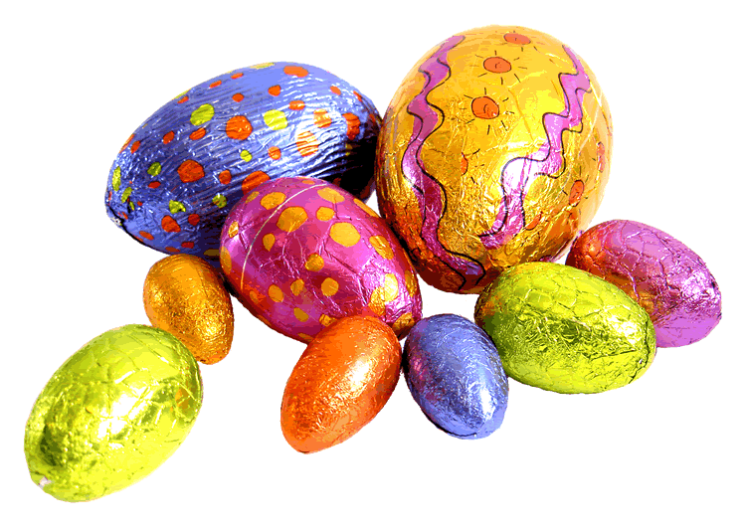
APRIL ACTIVITIES 2026 Center Hours – 7:30 AM – 2:30 PM

